Aras Fraud: a web of European “brokers”, using Dubai /UAE legal & financial system for a system of Fraud, enabled by banks & accountants/auditors for over €20m/80m AED of fraud to buy property/real estate in the UAE, Germany, UK + US IS and despite Dubai Supreme Court ruling against them, they continues to operate the international fraud out of Dubai, impacting Irish, European & US SME companies.
Table of Contents
Summary 2
The key individuals Emirates ID 4
How does Aras Consultancy (now Beyond Infinity) & Aras Group operate? 7
Previous convictions of key individuals involved & what we’ve discovered in three years 8
Evidence of repeating the criminal, commercial + financial fraud at scale 9
Contract signed with ARAS 15
Companies & Key people involved 21
Timeline of activities 22
Summary of key individuals + connections. 28
Commercial Judgement against Aras Group for Hikma/Rohmr. Taken in August 2021. Judgement August 2023. Still not enforced or assets recovered. 29
Companies who partner with Aras, Beyond infinity + other related groups on Real estate for transactions to increase fees from initial share capital (source of funds being the funds transferred from Aras etc to the brokerage) 30
Fake Credit Reports from Dun + Bradstreet as paid for by Aras to D&B employees 30
Method of fraud 32
Actions 33

Summary

A Dubai based entity called Aras Consultancy FZCO (now Beyond Infinity/Infinity Group), trading out of Dubai Marina office, claims to have the ability finance loans for the development of one of the largest projects in regional Ireland. It is run by German, Turkish & Indian management, with a network of German + UK brokers paid 20-30% from Aras for sourcing victims, with brokers paid 10 days after receipt of victims funds.
In August 2023, they were found guilty for the first time in Dubai. Ralf Jung + Ferhat Dogan.Of commercial fraud, following two years of obstruction of justice. Ralf Jung was found guilty of similar fraud and jailed for 7 years in Germany in 2010, prior to moving to Bahrain then UAE to repeat the fraud scam.
At project level, there was an Irish project that was supported with €110m of government funding and was a key project for Taoiseach, Leo Varadkar, and Ireland 2040 as North Quays SDZ Waterford aimed to create 7,000 jobs in the city directly + indirectly on the city-centre site, and the job creation required 2,000 homes to be built, having taken 4 years to get from concept to planning/delivery (2016 to 2020), with an Irish Executive who had delivered at scale for the Saudi group, Fawaz Alhokair overseeing growth from $350m to $8bn and 15,000 jobs in their retail business, a $12bn IPO and a $3bn renewables business alongside building c15,000 homes a year.
It was this Executive who was introduced to Aras by German brokers (Gehrmann Capital + Tilmann Bornmueller, who claimed to have completed projects with Aras before), via a UK broke, in August 2020, who then claimed to conduct 90 days of due dlilgence on the project (none was completed).
In November 2020, the Developer behind the project entered into a loan contract of €640m with the Dubai entity (Aras FZCO consultancy) as part of a supposed loan syndicate, following what Aras said was 3 months of due diligence & claiming a syndicate loan was in place with Dubai credible companies (Dubai Holdings name was used to add credentials) &Sovereign wealth funds.
It turned out no diligence was done, but that came to light through subsequent legal action and there was no syndicate & Dubai Holdings are not involved.
Aras’ German brokers sent through Dun + Bradstreet Credit reports stating they had >€100m revenue + $5bn in loans and >110m AED in paid up share capital, with the Aras Director saying they conducted many successful financing loans.
It was only in court was it found that these credit reports were paid for by Aras, paying individuals in credit agencies to create fake reports. The credit reports were false + misleading to make the victim believe Aras was real as part of due diligence. Aras have never completed a loan.
The Managing Director of the Irish entity (Hikma) visited Dubai Marina office of Aras twice in November 2020, and was asked by Aras to secure Government announcement of the €110m funding in November. He and the government did this in November 2020, announcing via Government website + national media the government funding for the project.
He returned again to Dubai in January 21 in person, having asked for evidence of funding + syndicate loan by the government.
The government announcement of funding was November 11th, 2020, showing the speed of urgency the Government had to respond to this request from Aras.

In November 2020, Aras Group were paid €755k by Hikma Real estate development for what Aras defined as SPV set-up & “consulting due diligence” for the loan contract, however, once paid from Hikma’s Bank of Ireland account in Ireland to Aras’ Dubai Marina account, Aras never set up the SPV, nor the consultancy, nor the syndicate loan, nor were never in a financed the projects.
No funds came through despite offer to set up Escrow to take receipt of funds until condition were met. The government asked for evidence. In January 2021, he was presented by a “Sheikh” and shown a fraudulent bank statement of Aras Group (Emirates Islamic Bank) stating they had over €650m to finance the project across 4 different currencies.
Instead of completing the loan, in November 2020, unknown to Hikma/Rohmr, Aras had instead sent €700,000 of the €755,000 in funds to their personal accounts on the day after receipt of funds from victims commercia bank (Bank of Ireland), as can be evidenced from their bank statement. Paid broker, paid staff in luxury watches + cash and paid german brokers ((Gehrmann + Tilmann) who were supposed to be representing Hikma, 30%.
The funds were never returned by Aras to Hikma, despite requests, as they transferred the funds to their personal and personal accounts the next day following receipt of funds, as evidenced on the bank statement we recovered 2 years later via Dubai courts.
Aras even was asked for another €750,000 fee to “avoid delays in finance.”
The delay to the project has cost not just the SME, but the Irish government a significant loss of trade (€150m a yr), the delay of 7,000 jobs and reputational damage to the Irish Government.

- It is illegal in UAE to sign a contract using false names which Aras /Beyond Infinity did since 2015 in every contract + continue to do.
- It is illegal in UAE to transfer funds out of a bank account into another account that is personal and/or use the funds for personal use, or to pay themselves, which Aras /Beyond/Infinity did and continue to do, as they then transfer the funds into newly set up bank accounts to avoid repaying funds taken from victims (e.g. Aras Consultancy took funds, transferred to personal + other accounts, then when court instructs Aras Consultancy to repay after 2 years legal process + costs, banks have no funds in the accounts they received the money to, have moved it to other accounts and can say to Court “we have no funds” leading to delays, or, the client goes bankrupt due to delays/legal costs, whilst Aras/Management continue to defraud using the new company.
- It is illegal in UAE to make a contract & invoice for services then not carry out these services, under commercial law.
- It is illegal in UAE to offer finance / loans without a financial licence, which Aras/Beyond/Continue to do as they do not have a financial licence nor operate in Dubai Finance District.Aras Consultancy have been banned in Germany by German Financial Authority (Government) from offering Loans, yet continue to scam/defraud in countries they are not yet banned.
- It is illegal to use a source of funds taken illegally to then purchase real estate in UAE or elsewhere, which Aras/Beyond continues to do today via “Beyond Infinity” real estate https://beyondinfinity.ae/ & Aras Group https://www.aras-group.ae/en
- It is illegal in UAE to take funds into a business (e.g. receiving funds into “Aras Property bank a/c”) claiming to carry out “consulting” when it’s a different business activity to the trade licence.

A legal case was taken by the Hikma + Rohmr against Aras, starting in August 2021 for costs + damages in Commercial circuit.
It has taken 2 years, but on 8th August, following Auditor/expert report appointed by the court, a ruling was made for Aras to repay only the €755k + interest. Not the full costs (as the solicitor didn’t include the €650k+ in expenses resulting from Aras requests, the loss of the projects profits (>€200m))
It is now December, and following court instruction to banks, Aras Consultancy Group has not paid.
Details behind the summary
Through the legal process and in the 2 year period since starting legals:

- It has come to light Aras has taken more than €15m from over 40 other European small companies and none have received funding, with their funds used by Aras personnel to buy properties, watches & luxury cars.
- Aras doesn’t have a financing licence to lend, and operates in Dubai Marina, not DIFC to offer lending (of c€640m euro or otherwise).
- Frank Kahn (Managing Director of Aras Consulting Group) real name is Ralf Jung. Ralf Jung was convicted of fraud & sentenced to jail in Koln, Germany, for seven years, in 2015. Released. The false name is used to avoid linkage to the fraud, as many clients who would find legal case of fraud would then not invest.
- Following the start of the Legal case against Aras Consultancy Group, Aras Consultancy Group changed it’s name to “The Infinity Group”. Aras did this to avoid linkage to the fraud case raised by the Irish company.

The key individuals Emirates ID

Aras Consultancy Groups operation is run by 4 key individuals; German, Turkish & Indian.

Ralf Jung (German passport # c4kn7VH02), using the fake name Frank Kahn in Aras Group/Beyond infinity. Mobile: +971 50 996 5089). Convicted of Financial Fraud in Germany on multiple occastions before moving to Dubai.
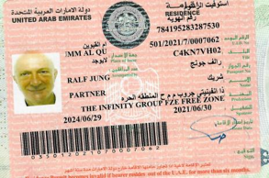

-Ferhat Dogan (passport U235923290), ex Director, now Managing Director Aras Group Real estate + Beyond Infinity. +971 588101168. Met Ralf Jung when in jail in Germany for Drug dealing.

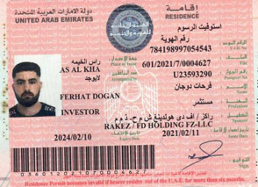

Samira (real name Radika Anupam Nemani): Ex Director of Aras, now Beyond Infinity Real Estate (sister company that takes money from fraud company, Aras/Beyond Inifinity, then sends across to Real estate)

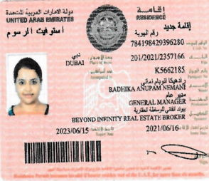

Altan Tulgar, now CEO of Auruntius Real estate, ex Infinity Group, which takes receipt of the funds

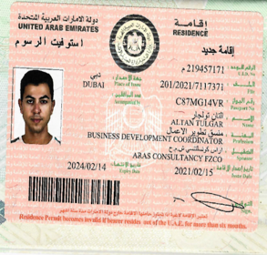

“Maria” aka Nidhi Singh (who received payments from Aras and now runs Real estate business in UAE called https://www.royalmanor.ae/ which is another real estate brokerage set up using some of the funds received from Aras)
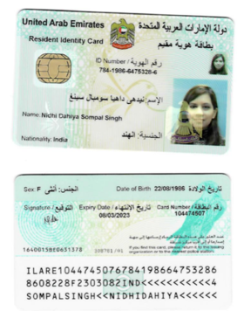

Achraf Mahmoud is CEO of Aras Group and keeps a distance from Consulting clients, but is very active on Social media. https://instagram.com/aschrafmahmud?igshid=YmM0MjE2YWMzOA==
Advertises now “how to make millions from investments in luxury watches”
https://www.youtube.com/watch?v=72hAVsR77T0

How does Aras Consultancy (now Beyond Infinity) & Aras Group operate?

- Aras operates out of a leased office in Dubai Marina, UAE, who claim to be able to finance multibillions in projects in their Dun + Bradstreet reports (“over $5bn loans issued”…through “Dubai & sovereign wealth funds” (they have no such relationships) with “>100,000,000 paid up share capital” (they have no paid up share capital as stated by management on Dun + Bradstreet reports), but haven’t a finance licence to lend (as required in Dubai, unlike in UK) & in reality, haven’t completed finance, as advertised, on any scale, and simply take in funds then pay their Directors to personal + their other business a/c’s.
- Aras Group are banned from advertising lending in Germany by the German Finance regulators (BAFIN) to German SME’s, so they use German & UK brokers to bypass the financial order, and use marketing to supress articles.
https://www.bafin.de/SharedDocs/Veroeffentlichungen/DE/Verbrauchermitteilung/unerlaubte/2017/meldung_170804_ArasGroupl.html
- By using fake name in all correspondence + emails + contracts, they avoid the web searches appearing during Due diligence and create falsified Dun & Bradstreet credit reports
- By targeting high potential, high growth, low cashflow European SMEs seeking growth capital, Aras claims to have syndicate finance with large, credible Dubai entities (such as Dubai Holdings) and uses such companies to attract small companies to gain credibility, but have no such consortium links with Dubai Holdings, and indeed, no syndicate finance.

- Aras operate based on a network of brokers in the UK, Germany & Europe, with these brokers refer clients Aras to the UK & European companies to finance the companies projects.

- Aras uses fake names to sign contracts of financing. This is fraud + illegal in UAE.

- Aras uses Emirates Islamic Bank, Abu Dhabi Islamic Bank and 4 other accounts

- Aras continues to create “new entities” to hide the fraud cases and funds.

Previous convictions of key individuals involved & what we’ve discovered in three years

- Ralf Jung was convicted of Fraud in Germany, before moving to Dubai in 2015.

https://www.gomopa.io/artikel/vorkostenbetrug-strafanzeige-gegen-algebo-nuernberg-und-aras-dubai/

- Jung moved to Dubai and invited both Achraf Ben Mahmut + Ferhat Dogan to Dubai, to set-up operations from UAE.
- In 2017, The German Financial authorities banned Aras Group from offering finance to German businesses, but Aras continued and offered “loans” via Brokers in UK, Ireland, Austria, Germany + Switzerland . In reality, there was no loans, but just a means to secure funds from SME’s.

https://www.bafin.de/SharedDocs/Veroeffentlichungen/DE/Verbrauchermitteilung/unerlaubte/2017/meldung_170804_ArasGroupl.html

- We found out through bank statements of Aras, received through the courts, that instead of representing the client, the brokers, unknown to clients, receive payments when funds are received by Aras by clients, two weeks after “the client” sends money to Aras UAE. That is illegal in Germany to receive funds from both parties and not disclosed.

- Aras, instead of carrying out the consultancy services and financing the companies in Ireland & Europe for which clients pay monies as per contract + loan commitments, transfers the funds received from “clients” to their personal accounts and/or business accounts of their other companies, which is then transferred as equity into Aras Real Estate to enable them to buy & sell properties. i.e. the fraud entity funds the real estate entity.

- The funds are never returned from personal or business accounts to their commercial bank account, nor to the client, and the finance never takes place. This transfer to themselves / business accounts / cash happens next day/within 5 working days.

- Aras then pay their brokers a % of 20% for sourcing of the fraud. None of the “brokers” in UK, Germany or elsewhere are regulated by FCA etc, and no broker declares the commercial relationship to “clients.”

- From discussions with German legal authorities (police are actively investigating them), other CEO’s and bank statements, it’s estimated Aras has taken over €20m from European clients since 2015 into Dubai and not completed one project, but used all the money for personal + other business use.

- Due to legal cases against Aras in Germany & UK by clients, Aras does not own assets in Germany or UK, instead keeping cash + property, estimated at now over €40m, in UAE. The same would be true for an Irish legal case against Aras; as the assets are in UAE, and it’s a UAE law contract, I understand the case has to taken in the UAE.
- As examples of the many frauds who are also seeking assistance with Dubai authorities, the following are just some payments of over €2m paid to Aras from multiple countries in the short space of 2 years. None of the companies have received payment or refunds and all CEO’s are wishing to discuss with Dubai authorities their fraud cases against Aras.
- Some of the SME’s have gone bankrupt as the monies taken by Aras sees significant cash + liquidity issues for the SME’s, the further €50k cost of legals and the 1-2 year delay of the legal system in Dubai; a clever tactic by Aras to delay legal preceedings results in SME’s going bankrupt.
- The bankruptcy from the Aras losses often results in the company being unable to make or continue a legal proceeding due to being bankrupt. A 3-6 month delay In “finance” due to Aras being terminal.

Evidence of repeating the criminal, commercial + financial fraud at scale

The following is a table format of companies defrauded by Aras + Directors from 2020 to 2021 as a snapshot from one of their six bank accounts.

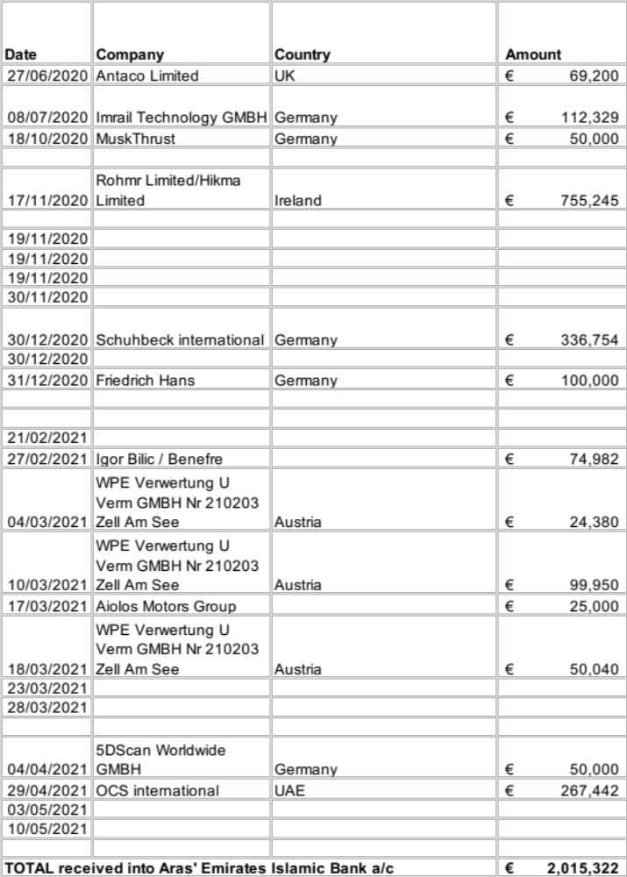

None of the above “clients” received any funding from Aras, nor recovery of funds.
Instead, the funds were moved into personal accounts, other of their business accounts and paid out in Cash.
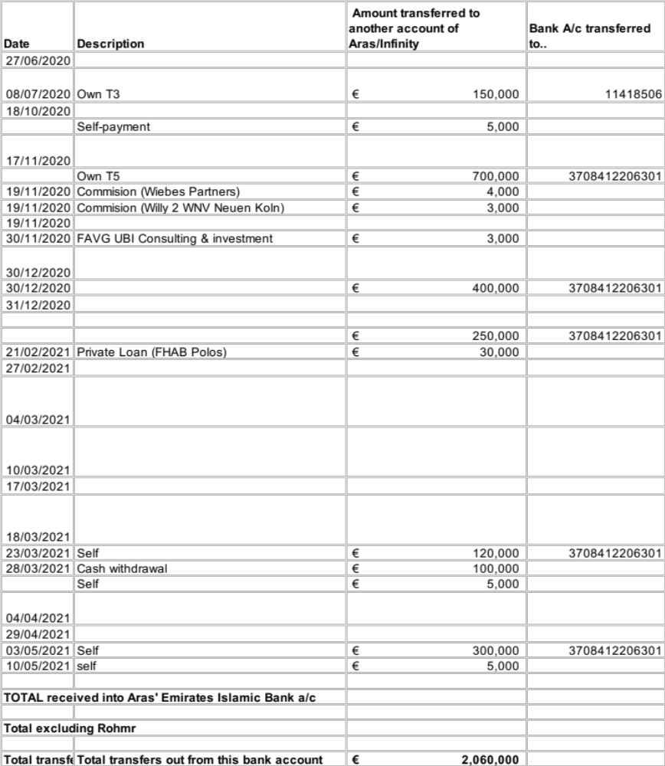

This is just one of Aras’ bank accounts, of which there are at least 6 in Dubai/Abu Dhabi.

The UK companies were asked to pay into NBD account, and over £1m was transferred across 3 companies in 2019 + 2020. Again, no funding was received.

Since 2021, Aras has “expanded” their operations to the US, and further clients in the US have paid €500k in 2022. They too haven’t received any funding.
Through the Dubai courts, this latter Irish company, Hikma received Aras’ bank statement, and having reviewed their bank account statement, it can be seen:

- Aras had no funds of significance, despite claiming to have completed over billions in financing transactions on their website; a false & misleading claim at the outset
- There was no finance consultancy or salaries paid to consultants to perform due diligence, despite claims by Director they had spent 3 months work on due diligence on the projects (which would have been significant consultancy if funding a €500m project)
- contacted the companies who paid funds into this account and via Linkedin/social media.

In addition to Ralf Jung being guilty of fraud for similar “operation” in 2015, the German legal system found Aras Consulting Group -UAE guilty of fraud in July 22 and is seeking more cases, with German authority in contact with Dubai Serious Fraud Office.

Aras operates with a network of brokers in Europe, none CFA / FCA registered, and it is through this network of brokers that Aras sources it’s client income. It is a a UK & European wide fraud operation. It’s understood by the German Fraud Office they have over 5 such bank accounts, defrauded over 40 companies with no contracts for financing completed.

A Group of victims have collectively shared information on Aras activities. From the four contracts related, the documents are attached.
What’s the summary timeline of activities for the irish entities Legal case in Dubai?

- August 2020: Aras Consultancy FZCO states they have completed 90 days of due diligence on the North Quays + housing projects and issue a Loan contract for €600m to Hikma Global Real Estate Development; an Irish entity. Their broker, German company Gehrmann Capital + Tilmann Bornmueller introduce Aras to Hikma (Irish entity)
- November 2020: Aras receives €755k from Bank of Ireland (Rohmr/Hikma) to finance the €600m North Quays & Housing projects, requesting the Irish government to confirm €110m of funding.
- November 2020: Irish Cabinet announce funding of €110m for North Quays.

Official Government announcement (https://www.gov.ie/en/press-release/54654-minister-obrien-announces-urdf-funding-of-806m-for-waterford-north-quays-project/
November 2020: Aras pays the brokers, Gehrmann + Bornmueller a fee of €4,000 2 weeks after receiving payment from Hikma’s funds. This is illegal in Germany to get paid by “client” and “financier.” It is then shown that brokers get 20% of any “fees” paid to Aras Group for sourcing.

- December 2020: Hikma informs Bank of Ireland that €70m of funding is to be received from Aras Consultancy FZCO. Bank of Ireland informs Hikma that Aras Consultancy FZCO has failed KYC / AML and the transfer won’t be accepted by Bank of Ireland. This red flag is raised by Hikma with Aras, as it now causes a delay to finance. Aras say KYC fail is normal during Covid times.
- January 2021: Irish Government request evidence of funds & the syndicate loan behind Aras Loan Contract for due diligence to check source of funds for the North Quays as a State project receiving €100m+ in taxpayers funds. Rob Cass, Managing Director, Hikma, flies to Dubai during Covid peak and at a meeting in Dubai, Aras shows a bank statement of over €600m of funds supposedly in Emirates Islamic Bank, with intent to share with government. Aras refuses to send electronically and it transpired this bank statement was fraudulently created by Aras as it could not be shared with solicitors or Irish Government to confirm funds on account. Hikma are requested to pay costs of €200k, by Aras, changing the nature of the contract, and Aras incur over €140k of legal costs for changes requested by Aras with their solicitors (Simmons & Simmons) to the contract with Irish Government, as finance is now 3 months later than Irish government contract.
- February 2021: Aras requests another €750k fee to be paid into their account. Hikma Executive refuse, offering payment into pre-approved Escrow with Citigroup, as there is still no evidence from Aras of syndicate loan, nor payment into Escrow of the first tranche (€110m) as per government requirements, or, “as approved and the funding for the loan is aleady in place.” There was no loan, no syndicate. No funds as unable to send funds into Escrow.
- May 2021: Aras are unable to confirm evidence of finance and the Government cancels the contract with Hikma for North Quays, resulting in project loss to Hikma (€80m loss), 2 year delay to North Quays /7,000 jobs delayed and the 2,000 housing supply project lost (further €80m loss). Threaten to email Municipality, who themselves had raised questions having found articles online re: Dubai scam.
- July 2021: The North Quays funding delay is raised in Irish Parliament, with the Taoiseach embarrassed into addressing delays of the government project as the “Difficulties relating to it have not been on the State’s side” (i.e. the funding delay by Aras were the issue).
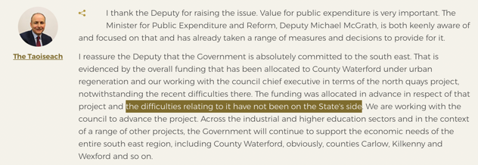
- August 2021. Hikma Global Real estate Limited start a legal case against Aras group (commercial case), following investigation of Aras.
- November 2021, when the court case started, Aras Group renamed to Beyond Infinity
- January 2022: Aras group delay legal process, claiming no payments were received, which the court then had to request bank statements.
- May 22: Bank statements received through the Dubai courts of Aras for the account paid by Hikma/Bank of Ireland. Aras bank statements shows payments for the €755,000 as per contract with the Irish entity, and Aras had lied to the court as a means to delay the ruling and continue operating.
- March 2023: some 18 months after commencing legal action in UAE, the court appointed an auditor to rule the amount to be refunded by Aras to Hikma Global (i.e. Aras are instructed to repay Hikma and in instance
- The auditors report took two months, and in May, was presented to court
- The auditor report, available to view by other victims / Fraud office upon request from Hikma, concluded Aras had been paid, had received funds to Aras’ bank account, contrary to claims made by Aras in November 2021 and Aras were to repay the payments made by Hikma, plus interest
- The ruling was postponed from 21.06.23 to 07.08.23 by Dubai Courts with no reason given for the further two month delay
- Aras have commenced Power of Attorney transfers from Ralf Jung to Ferhat Dogan for Beyond Infinity + Aras Consultancy to move money/assets out to avoid payment

What help & assistance is required from authorities?

- We are happy to give all documents and all contact details for all companies CEO’s affected by Aras; we are a group of over 30 CEO’s seeking to stop fraud, recover funds and continue our businesses which have a positive impact on trade + communities across many sectors. If we all share and collaborate, we all reduce the trauma that this fraudulent Group has had on many, many companies + lives.
- For Ireland, we would like the Irish Embassy’s help, via their significant influence with UAE authorities, to ensure Aras Consultancy Group /Beyond Infinity Group, Ralj Jung, Ferhat Dogan/Achraf Mamut, Altan Tulgar + others and the manner in which it defrauds SME’s, is stopped or penalised.
- The manner of fraud acts to the detriment of business trade and livelihoods, not just the damage to reputation of Dubai and Ireland when large scale projects that change communities outcomes for the better are stopped or lost completely due to fraudulent activities by a few.
- The manner in which Aras circumvents law and the financial sector undermines authorities in Dubai/UAE, even pretending to be “Sheikh’s” when meeting clients in their Dubai Marina office.
- The operation of lending from Dubai Marina isn’t legal: loans / finance requires authorisation & a licence from Dubai financial authorities.
- The activity is fraudulent to receive monies for services / products that are never completed
- The transfer of businesses’ hard earned funds to Aras and then to their personal accounts is a further criminal activity.
- The authorities in Dubai to made aware that civil cases have been raised, but the fraud operation is across multiple countries and impacting thousands of lives amongst many countries at a large scale, particularly given Aras targets small businesses with high growth potential that are the lifeblood of trading economies.

Contract signed with ARAS

N.B The contract was for €640,000,000.
Aras advertised they had completed financing and had funds. Their bank statement received after the contract showed they were no funds and they hadn’t financed contracts for others, nor, did they have a finance trade licence for Dubai.

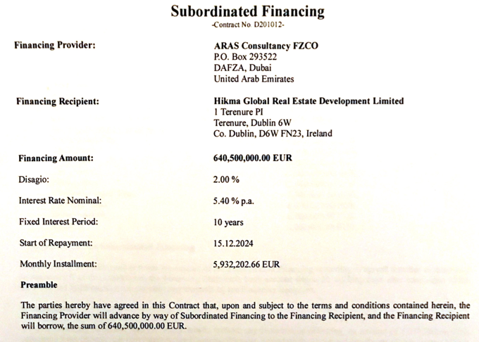

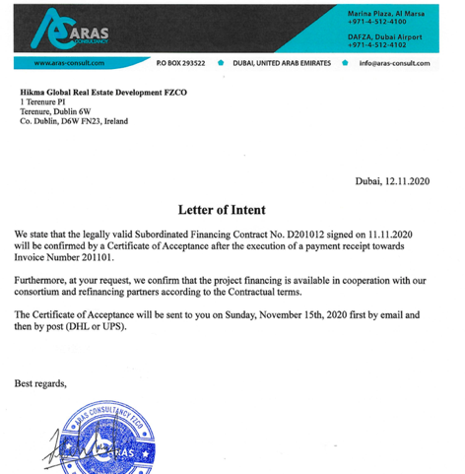

The signature of Aschraf Mahmut and Frank Kahn uses a fake name to enter into contract.
Invoice.

It is not normal to pay consultancy fees for due diligence by the financier; it is normally part of the fee (1 to 1.5% of the amount of funding, as the fee is large).
The IP on the due diligence / works would be then be the IP of the payee (client) having paid for these “services”. Aras never completes the consultancy as evidenced in their bank statement.

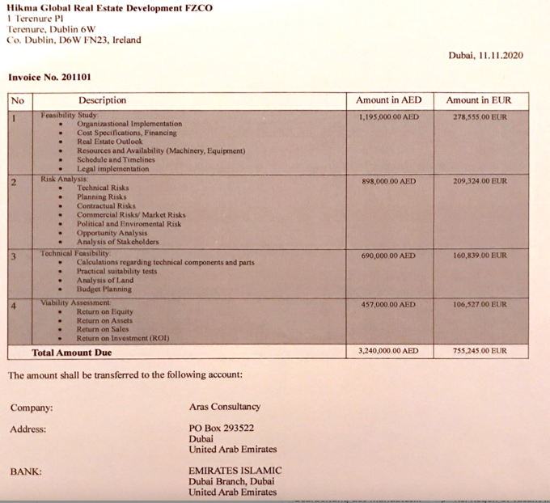

Aras Consultancy FZCO bank statement
On 17-11-20, payment from Bank of Ireland REF Hikma to Aras Consultancy FZCO Bank account in Dubai Marina (now named Infinity Group FZCO) for the €755,000 as show in Aras bank statement.
Then immediate transfer of €700k to their personal accounts: No consulting completed/paid for. No funds of €640,000,000 to transfer / finance are In this, or their other bank accounts, as falsely stated by Aras. Then “payment to their real estate business” happens on 18-11-2020.

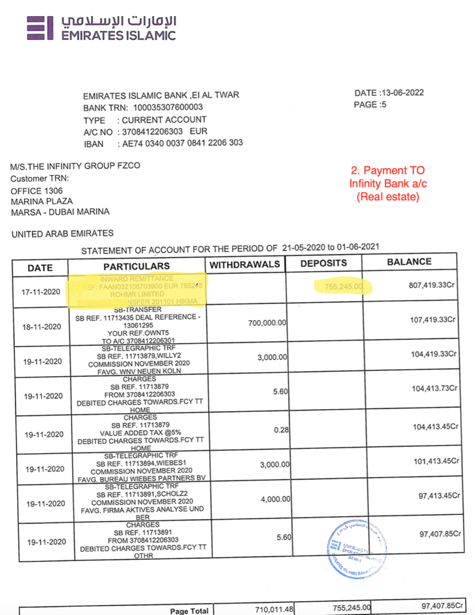
3. Payment to themselves
- Our payment

Examples of the “contract” signed by Aras with fake names, which is an illegal activity in UAE.

Bank account of Aras showing there was no sizeable funds, no consultancy costs paid as per invoices and personal account.

The account starts with zero, has then nominal funds, rather than funds from the $5bn in loan issuances advertised/claimed, then gets a payment for a financing contract, then pays the funds to their own account immediately and then doesn’t pay any financing or consultants as per invoice.

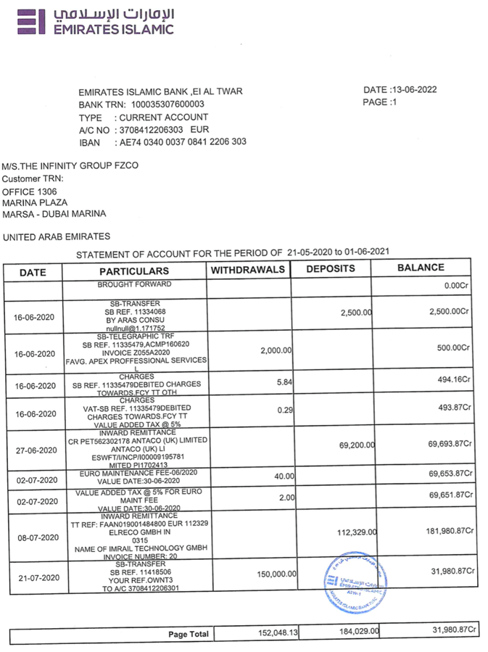

Companies & Key people involved

Companies traded as and trading as
- Aras Holding FZCO
- Aras Property FZCO
- Aras Consultancy FZCO
- Infinity Group FZCO
- Beyond Infinity Real estate FZCO

Altan Tulgar, Hafiz Muhammad

- Infinity Group FZCO
Ralf Jung (aka Frank Kahn)
Nidhi Dahiya (aka Maria Zain)
Radhika Nemani (aka Samiha)
Ferhat Dogan
Altan Tulgur
Akash
Rabia
Gabriel Oduor Ochieng
Hafiz Muhammad
Vlodymir Romanjuk

4. The Infinity Group LLC Qatar
Ralf Jung
Ferhat Dogan

5. Beyond Infinity Real Estate
Nidhi Dahiya
Radhika Nemani
Ferhat Dogan
Altan Tulgar
Abdul Nazer Nalakath

6. Beyond Infinity Feasibility Studies Consultancies

Ralf Jung

7. Beyond Infinity Social Media Marketing Co.

Altan Tulgar

Selim Mohammed

Ferhat Dogan

Timeline of activities
2010
Ralf Jung is taken into custody in Germany, having been part of Hypoleasing scammed more than 100 customers for between €3,000 to €350,000 in forward fees for financing

Whilst in Cologne prison, he meets Ferhat Dogan and ALi Reza B, see news article below.

Ferhat Dogan is in prison for burglary and is a drug addict. RJ's story impresses FD greatly.

Delivery to Cologne

02.03.2010 EXPRESS / COLOGNE

https://www.genios.de/searchResult/Alle/Presse?requestText=millionen-Betr%C3%BCger+k%C3%B6ln+ralf+jung&offset=90&size=10&sort=BY_DATE&order=desc&resultListType=DEFAULT&view=list

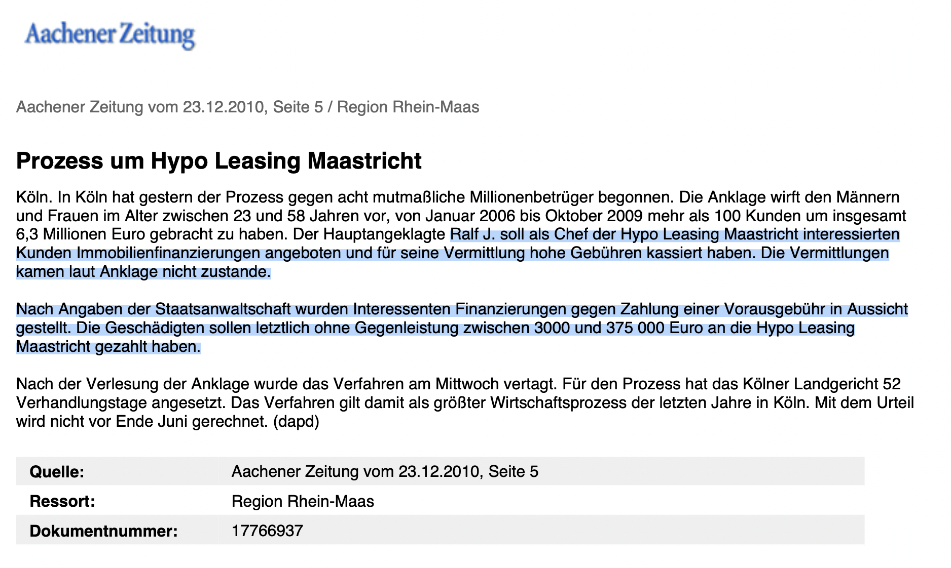

Ralf Jung is released from jail in 2014.
“7 million scammers are released”

12/16/2014 EXPRESS / COLOGNE by FLORIAN JOCHAM Cologne

2014 – 2016

Ralf Jung acts from Germany.
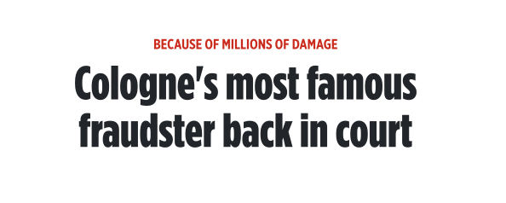
In detention he meets ALI Reza B, who supports him in founding a company abroad, and loans from Bahrain are used to advertise the business to Europeans.
Ralf drives a leased Rolls Royce Phantom to impress his customers.
The car will be handed over to Ferhat Dogan's father at the end of 2016. This car is still in use in Dubai as seen in Ferhat’s Instagram posts as recent as December 2023 to impress social media followers that Ferhat is legit and makes millions..
The German office is located at Mainzer Str. 47, 53179 Bonn, according to a consumer protection blog entry. Which is Achraf Mahmut’s home.

https://verbraucherschutzforum.berlin/2016-08-17/aras-group-ae-finanzierungsberatung-und-vermittlung-ueber-das-ausland-immer-vorsicht-walten-lassen-177794/

End 2016 -2020

Ralf Jung leaves Germany, flies to Dubai and is now very successful using the false / fake name of “Frank Khan” in Aras Group and then Aras Property with his work colleagues:

- Nidhi &Vikaz (Spouse of Nidhi, who pretends to be a Sheikh in front of fraud victims when they visit Dubai office)
- Hafez Muhammad
- Akash & Rabia (Spouse of Akash )
- Achraf Mahmut (who also pretends to be a sheikh too)
UK company + German company send funds and upon no receipt of funds, begin legal, resulting in new entity being created: Aras Consultancy FZCO.
Funds removed by Directors from Aras Group + Aras Property to show no assets (to avoid legal repayment).

2020 – 2021

Legal cases taken against Aras Consultancy FZCO Group (by Irish Companies (Rohmr / Hikma). Ralf Jung has problems in Dubai and takes his colleagues with him to the newly founded companies. Begins as Beyond Infinity
He contacts Ferhat Dogan and asks him to come to Dubai immediately and support him in these new companies.
Ferhat Dogan has his visa through FD Holding and is responsible for Infinity Group compliance; he is trained by Ralf Jung and Willy Neuen (german) on processes + practices.
Willy Neuen handles all compliance cases and is based in Germany with his property management company, and he receives commission from Aras Consultancy.
Neuen sets up and operates a Abu Dhabi Real estate Brokerage /property management company in UAE, believed to be another source of outflow of funds from Aras/NewCo each time. Their office in Dubai is the same tower as “Aras” (Marina Heights)
https://www.algebra-property.com/about/
https://www.neuen-verwaltung.de
Nidhi Dahia goes from secretary to managing director of Beyond Infinity Real Estate (Broker/Property management) and right hand of Ralf Jung in Infinity Group
She is down as “Maria Zain “ in all emails from her to clients and also provided the information to the false Dun + Bradstreet Report which states Aras Consultancy/Infinity Group has more than 100,000,000 AED share capital paid up. Bank accounts show none of that capital exists, but the report from Dun & Bradstreet and statement from “Maria”were false + misleading; to use a fake name, make false statements, which then leads to SME’s paying for a credit report that is fake (but gives illusion Aras is a large group, prior to signing contracts).
Radhika Nemani & husband are close friends of Nidhi and Radikha is also Managing Director of Beyond Infinity Real Estate. Her husband often plays the sheikh when signing contracts (impersonating an Emirati).
Akash & Rabia (spouse) (clerks)
Hafiz (IT)
all listed persons receive sales commissions: 10% of the proceeds and the broker or the initial introducer is paid commission (as evidenced in bank statement) or receives cash (as evidenced by cash withdrawal) or luxury watches (as evidenced from internal source that following payments).
2022

Ralf Jung's right hand, Nidhi, gets funds from Aras and sets up another real estate brokerage company in UAE; https://www.royalmanor.ae/
She is replaced by Altan Tulgar (Turkish-German) met in Germany, associate of Ferhat Dogan.
Having previously worked under Nidh to learn the fraud processi,Altan is now responsible for the entire Infinity Group team and is bringing good revenue to the business.
Abdul Nazer Nalakath changes from helper to Infinity Group accountant to oversee movement of funds from victims to companies and Ralf becomes the lead for the finances. No accounts are ever filed with authorities, no VAT paid, and this transfer and lack of accounts are overlooked by Emirates Islamic Bank and Emirates NBD who have individuals within compliance to be be paid ¢50,000 to pass KYC and in turn, the banks create new bank accounts for the new companies.

Marketing needs to be expanded, Ferhat Dogan brings Selim Mohammed (YouTuber) into the company. He coordinates the marketing for all of Ralf Jung's ventures, as efforts now go on expanding marketing to Germany, Russia + US via Social media celebs.
Social media of millionaire winning celebs used to push traffic to “Dubai Real estate opportunities” across four real estate broker companies they own. One focuses on German, one on Russia, one on UK + US, one on Indian.
2023

Creates another new companies in Dubai called Aurantius Real estate and transfers the money taken fraudently from “clients” of Aras/Beyond Infinity into this company.
Still has same PRO/email as fraudulent and still has Ralf Jung as Director/owner.
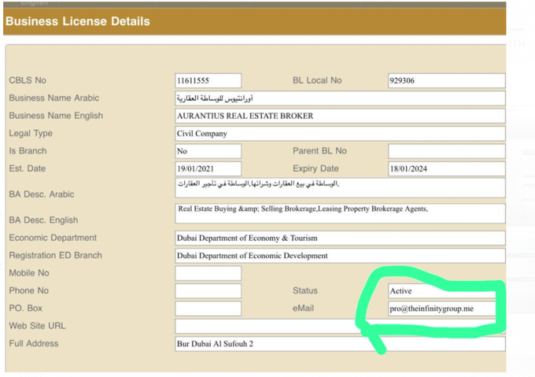

Summary of key individuals + connections.

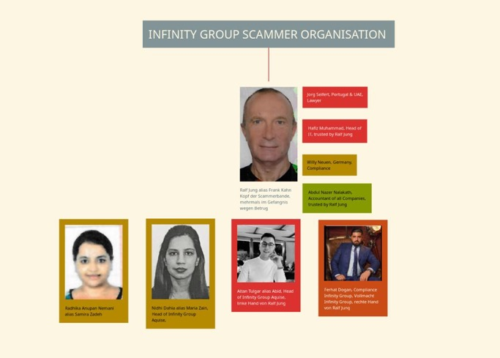

Commercial Judgement against Aras Group for Hikma/Rohmr. Taken in August 2021. Judgement August 2023. Still not enforced or assets recovered.
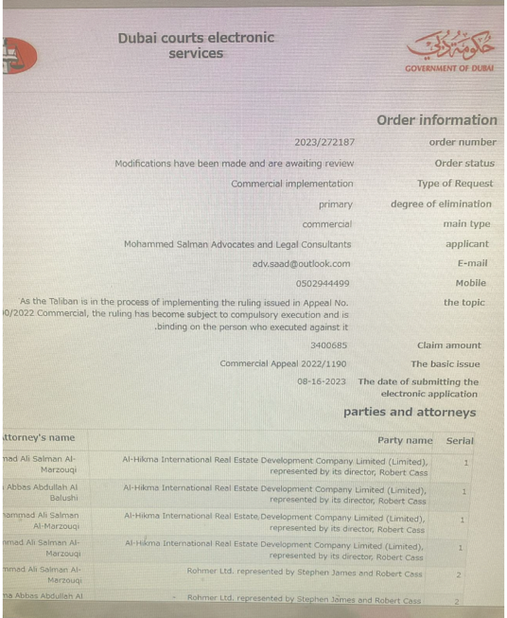

Companies who partner with Aras, Beyond infinity + other related groups on Real estate for transactions to increase fees from initial share capital (source of funds being the funds transferred from Aras etc to the brokerage)
Damac
Emaar Group
Property Finder
https://www.aras-group.ae/en
https://aurantius.ae/our-partners/ Is their new real estate company located at the same address as Aras Group in Dubai Marina, to whom the company transfers funds to wash through for real estate and onward.

Fake Credit Reports from Dun + Bradstreet as paid for by Aras to D&B employees

Aras Property + Aras Group + Aras Consultancy + Infinity Group have all issued fake credit reports since at least 2019 to mislead SME’s as to size.
Fake Dun + Bradshaw report : there are no assets of >100m AED within the companies mentioned, nor $5bn of loans issued. This is false + misleading.

https://www.dnb.com/business-directory/company-profiles.the_infinity_group_fzco.371184976ecc05ca030abc68cec335e5.html

Fake Dun + Bradstreet reports issued by credit agencies designed to mislead SME’s that Aras had scale.
No funds existed as per below from the credit report cross-referenced against bank statement.
Legal counsel to Aras made false + misleading statements to Dubai judges that it is Commercial dispute and Aras has funds; bank statements shown to Court show there is no funds.
Fake statements of credit reports + no trade licence for offering finance (debt + equity) are not questioned by Dubai judges.
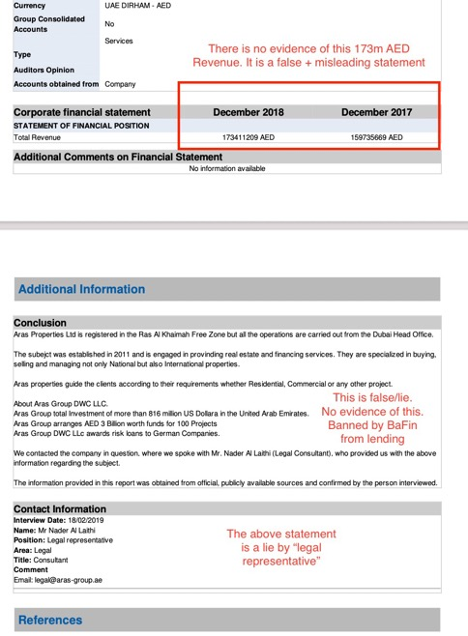

Method of fraud
- Advertises to SME (working capital constrained) that ability to finance and promotes projects financed on website (none have been completed)
- Sends fake Dun + Bradstreet report via broker for credibility
- Sends due diligence questions including Wealth statement
- Sends Letter of intent
- Sends Loan contract
- Requests payment to establish SPV to take loan proceeds into (happens to be 50% of wealth)
- Sends invoice for payment detailing “consulting costs”
- Takes payment into one of multiple UAE bank accounts
- Changes terms of contract and requests more information for due diligence
- Delays loan drawdown
- Cannot evidence loan contract or syndicate
- Threatens SME with legal action for changing contracts
- SME changes contract
- Asks for more funds /payment (remaining 50% of wealth)
- Client cancels “contract” when funds not received or projects lost due to finance delays of 3-6 months
- Fraud threatens loss of fees
- SME threatens legal
- Solicitor sends letters to cease + desist to SME
- SME stops projects or goes bankrupt having run out of funds (wealth/capital) that was
- SME unable to go legal due to lack of funds (wealth sent to fraud)
- SME goes bankrupt
- Fraud then repeats with other businesses
- Fraud pays funds from the bank account to brokers, their own personal accounts, loan + subsidiaries under new name
- Subsidiaries expand operations to real estate brokerage + other countries
- Old company of fraud that took original funds now has no assets to be pursued
In each case, the money received from the victim is moved from the company to the new company (real estate brokerage). No assets remain. Judgements take years. Resulting in the entity taking the case going bankrupt.
The legal case is against the old company. It takes 2 years. In UAE law (not DIFC, nor UK, nor IRL, DE or US).
A new name + new company is set up in that 2 years.
The money is transferred to the new company, with commission paid to broker + staff for securing the fraud, and payment to bank + Dun + Bradstreet employees to create new entities.
The solicitors + banks report no assets (in that company with the old name), but do not check for assets in new company against Directors (personal + real estate brokerages).

Actions

Organise call with the German / Austrian companies to collectively act and evidence to state prosecutors
Question the key individuals, past + present
Question Dun + Bradstreet, banks & accountants re: credit reports
Question brokers in DE + UK as to knowledge
Question former employees who now operate
Inform embassies and collectively act.

